HORIZON ENTERPRISE IMS
Module Requirements Template
Module: [Maintenance]
Submitted by: [Richa]
Date: [14-Jul-2026]

COLOUR GUIDE
GREEN — Example value from MAINTENANCE Call Allocation— replace for your module | BLUE — Empty slot — add your own rows here | AMBER — Instruction — read once, ignore after

HOW TO USE THIS TEMPLATE
1. Save a copy — rename to MRD_[ModuleName].docx before editing.
2. Replace every green value with your module's equivalent (SP names, RB codes, field names, routes, etc.).
3. Add your own rows in the blue slots at the bottom of each table.
4. In Section 2, delete the placeholder box and paste your design screenshot (Insert → Pictures).
5. Send completed document to the development team BEFORE coding starts.
6. Dev team signs off by stamping "Dev Confirmed" on each section.

1. Module Overview
Replace every green value below with your module's equivalent.
Module Name: Maintenance
Module Code: “MNT”
Purpose: to allocate call against assets item complain.
Primary Users: Procurement / Maintenance Team
Listing Route: /Assets- MAINTENANCE CALL ALLOCATION
New Form Route: / Assets - MAINTENANCE CALL ALLOCATION /refresh
Nav Menu Label: MAINTENANCE CALL ALLOCATION

2. Screen Design
Delete the placeholder box below and paste your design screenshot (Insert → Pictures). Add a second image for the listing view if applicable.

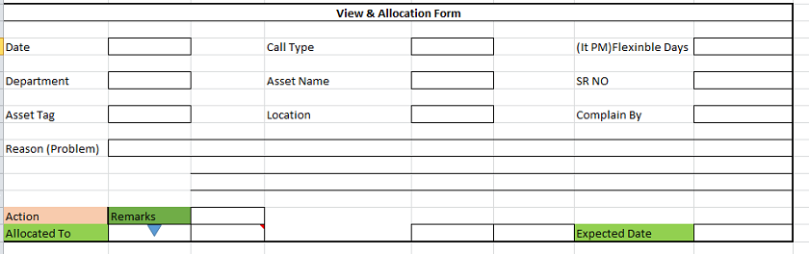
Note- do not copy color /back color from design.

Screen notes / layout description:
Describe each visible area: panels, tabs, special controls, conditionally visible sections.
► Header panel — trandate (System Date), calltypename (textarea), flexibledays (TextArea), deptname (textarea), assetname (textarea), srno (textarea), assettag (textarea),
location(textarea), employeename (textarea), reason (textarea),remarks (textarea),
allocateduserid (Dropdown), expecteddate(Date Time)

With RB Name(rb_mntallocation)

3. Header Fields
One row per field shown in the Header Panel. Control types: Textbox | Date | Dropdown | Textarea | Checkbox.

Field Label | Field ID (ColName) | Control Type | Required | Is Read Only | Source SP / Cascade Note
Date | trandate | Date | Yes | Yes
Call Type | calltypename | TextArea | No | Yes
Flexible Days | flexibledays | TextArea | No | Yes
Department | deptname | TextArea | No | Yes
Asset Name | assetname | TextArea | No | Yes
SR No | srno | TextArea | No | Yes
Asset Tag | assettag | TextArea | No | Yes
Location | location | TextArea | No | Yes
Complain By | employeename | TextArea | No | Yes
Reason | reason | TextArea | No | Yes
Remarks | remarks | TextArea | No | No
Allocated To. | allocateduserid | Dropdown | Yes | No | fn_gen_fetchallocateduser(@prmcompanyid int,  @prmdivisionid integer,  @prmlocationid integer,  @prmdeptid integer)
ExpectedDate | expecteddate | DateTime | Yes | No | Default: (today's date )
(add here) | (add here) | (add here) | (add here) |  | (add here)

Cascade resets:

5. API Reference
List every stored procedure / function called. ObjType 2 = Function, 1 = Procedure. Source: backend DBA.

SP / Function Name | ObjType | Purpose | Key Parameters | Returns
Fn_Fetch_RBDetailByRBCode | 2 | Fetch RB column metadata (header + detail) | prmRBCode | Table[0]: RBID + column definitions
Fn_tbl_FetchUserWsDivision | 2 | Division dropdown options | prmYearID, prmLoginID | Table: division list
fn_tbl_rb_mntallocation | 2 | TO load data in popup form | @prmcompanyid int,  @prmyearid int,  @prmloginid int,  @prmsessionid int,  @prmmasterid int,  @prmrbrowid int
(add here) | (add here) | (add here) | (add here) | (add here)
(add here) | (add here) | (add here) | (add here) | (add here)

Save endpoint (REST POST):
Endpoint path - - API/ MntAllocation/ Post_RB_MntAllocation_Save

Payload keys: prmStrMstJSON | prmStrDetJSON

5.1 RB Structure Detail

SP / Function Name | RB Name | Purpose
Master Data RB | rb_mntallocation | Load Master Controls in form
Item Detail Grid | -
Search data | -
RB Save API | API/ MntAllocation/ Post_RB_MntAllocation_Save
List side Data fill | -
Edit Mode – Master | fn_tbl_rb_mntallocation | @prmcompanyid int,  @prmyearid int,  @prmloginid int,  @prmsessionid int,  @prmmasterid int,  @prmrbrowid int
Edit mode – Item Detail | -

6. Business Rules
Every rule the developer must implement. Add or remove lines for your module.

1. (add here)

7. Constants (constants.js)
All values for the constants.js file. RB codes and SP names come from the backend DBA. Mark CONFIRM = Yes if value is uncertain.

Constant Name | Value | CONFIRM? | Notes
RB_MASTER | rb_mntallocation | No | Master board code — header column metadata
RB_DETAIL | - | No | Detail board code — grid column metadata
FORM_TAG | rb_mntallocation | No | Short module tag used in save payload
TRAN_BOOK | MNTALN | No | Transaction book name for item picker SP
CONFIG_YEAR_ID | 2 | CONFIRM | Year ID passed to configuration SPs
DIVISION_YEAR_ID | 2 | CONFIRM | Year ID passed to division fetch SP
SUPPLIER_PARTY_TYPE | - | No | Party type filter for supplier picker
LIST_OBJ_TYPE | 2 | No | OBJ_TYPE.FUNCTION — for listing SP call
SP_ LIST | - | CONFIRM | Function to load listing page data
LIST_DIVISION_ID | 15 | CONFIRM | Default division ID for listing data fetch
SAVE_ENDPOINT | API/ MntAllocation/ Post_RB_MntAllocation_Save | No | REST gateway save path
STORAGE_HEADER_META | piHeaderMeta | No | localStorage key for cached header RB metadata

— END OF TEMPLATE —

